Susan and Bill (from USA): India trip report
9-15 Dec, 2014

Tour organizers: Manoj and Harsh Vardhan,
VIGT, Individual and Group Tours, www.ourindiantours.com

My husband and I made our first trip to India in Dec, 2014. Our primary interest was to observe and photograph tigers in the wild. We were also interested in other mammals, birds and some cultural sights. We wanted a private tour so we could control where we went and amount of time spent in each area. Manoj and Harsh Vardhan at VIGT were both extremely helpful in planning the trip, arranging it exactly as we wanted, at a reasonable price and with all very helpful, knowledgeable and friendly guides along the way. I highly recommend this group for touring in India.

Our itinerary:

9 Dec- New Delhi. Harsh Vardhan and our driver, Pawan met us at the airport. Harsh guided us on a short tour of Delhi, showing us Humayu’s Tomb and several other places of interest. We thoroughly enjoyed getting to know Harsh. He is very involved in Indian wildlife, particularly birding. He was also very knowledgeable about the cultural sights. We enjoyed spending the afternoon with him, he is a true asset to wildlife in India and it was a pleasure talking to him.

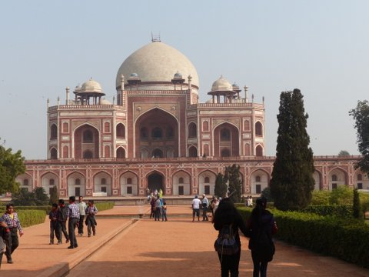
Humayu’s Tomb

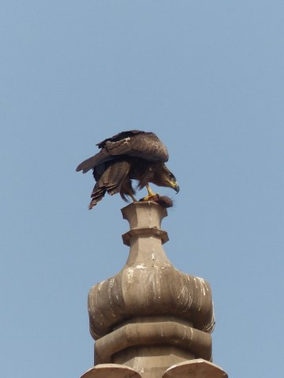
Black Kite

We dropped Harsh off and Pawan drove us on to Agra where we spent the night.

10 Dec- We toured the Taj Mahal and Red Fort. Our guide was arranged by IGT and he was very good. Pawan continued driving us around Agra. If you’ve visited India you know what the traffic is like, so just let me say Pawan did an excellent job and we were very happy to have him in charge of the driving! Pawan took us to the train station in the afternoon,he helped us get food to take along, and waited with us until our train arrived. He then made sure we got to the correct car and berth before sending us on our way.

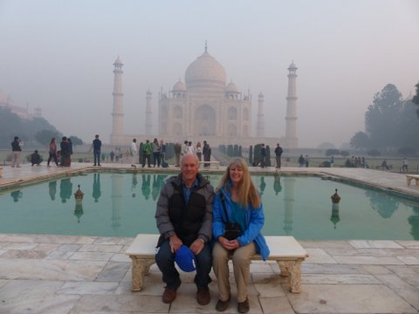
Bill and Susan at Taj Mahal

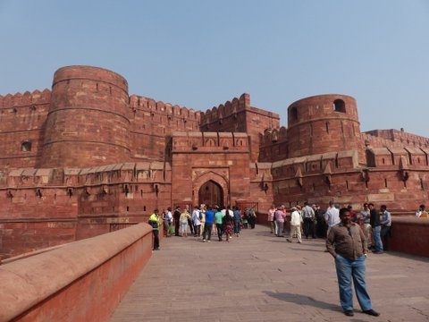
Red Fort, Agra

11-13 Dec- Bandhavgarh. We overnighted on the train and were met by another driver at the train station in Umaria. He took us to the Jungle Lodge by Bandhavgarh. There we met our guide for our time in the park, KDKargeti. The Jungle Lodge was very nice, great location, excellent food and we loved KD. KD was very enthusiastic about finding wildlife, identifying birds and simply a nice person to spend time with. We were very fortunate to find a pair of tigers that were willing to spend their day near the road, giving us many photo opportunities! We took hundreds of photos and had a wonderful time!

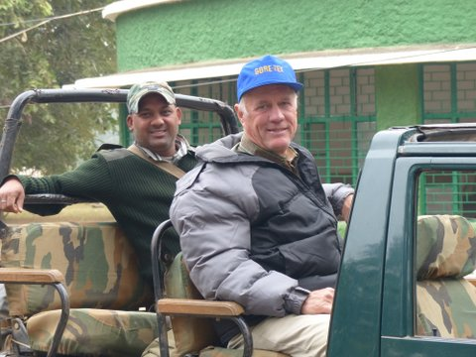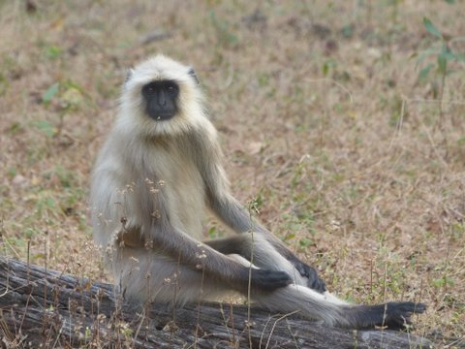
KD and Bill ready to go into Bandhavgarh NP Gray Langur

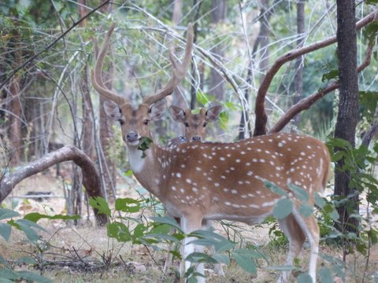
Spotted Deer

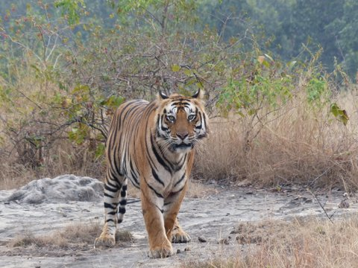

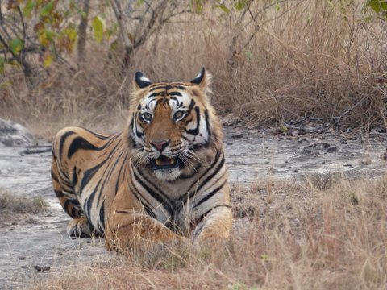

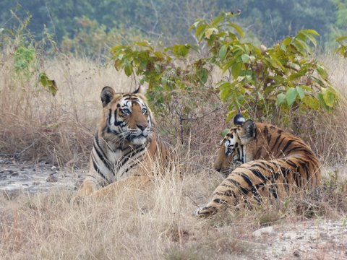

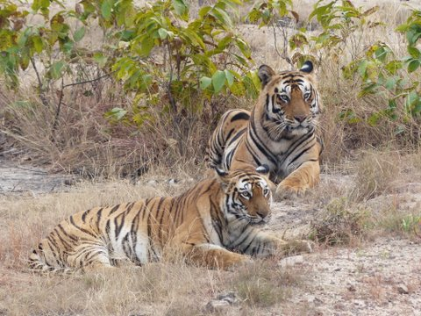

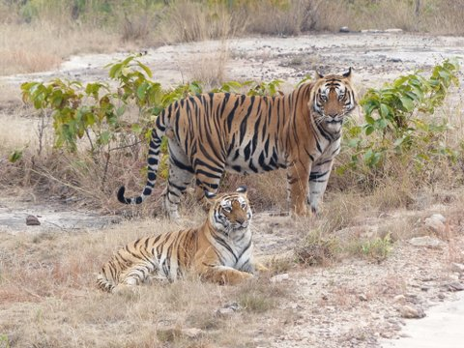

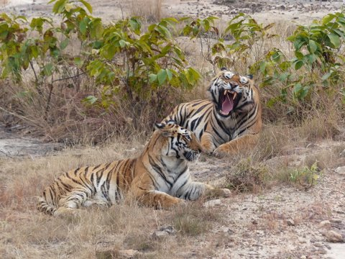

Our driver returned and took us back to the train station. Again we were assisted in finding our coach on the train.

14 Dec- We arrived back in Agra and were met again at the train station by our original driver, Pawan. He drove us to Bharatpur and Keoladeo National Park. There we met another 1st rate guide, Satya Bhan. Satya is an excellent birder, helping us identify about 100 species of birds in just an afternoon and a morning in Keoladeo. He was very happy whenever he spotted a more unusual bird and that made it particularly fun for us. We had cloudy weather which was not good for photos, but had a great time anyway.

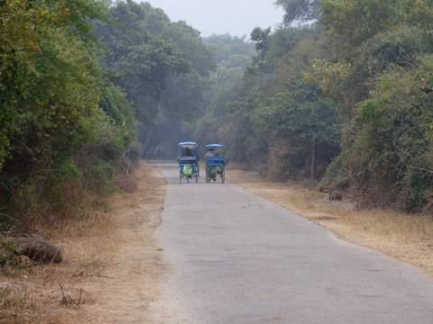
Keoladeo National Park

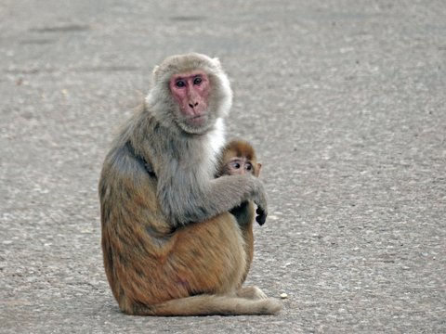
Macaque, Keoladeo NP

15 Dec- Morning in Keoladeo. Pawan drove us back to New Delhi and to the airport.

We were very happy with IGT and all the arrangements they made for us. Everything went very smoothly. All guides and drivers were always on time, we never had to wait for any of them or worry that we were going to be late to catch our trains. We did not have to worry about where we needed to go, the drivers took care that we were comfortable before leaving. Everyone we had contact with from the lodging, to drivers and guides were all very knowledgeable, friendly, and helpful.

We (based in the US) will definitely contact IGT again if we decide to make another trip to India. I highly recommend them to anyone visiting India, but particularly to anyone interested in wildlife, mammals or birding.

